1. Arc and Sector

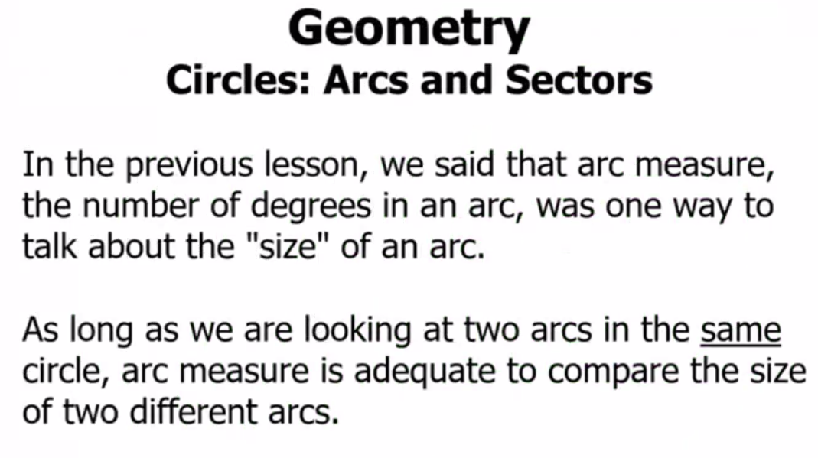

1. Two Points Measurement

1. How to find Arc length

1. Formulae for arc length

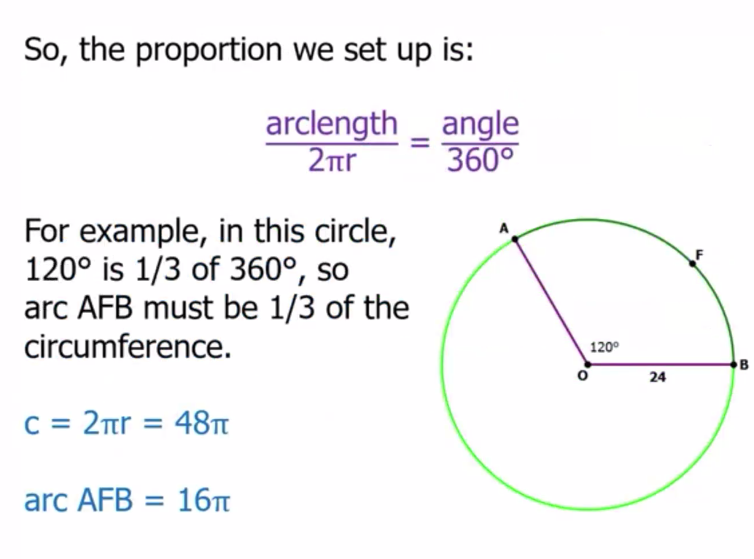

1. Arclength problem

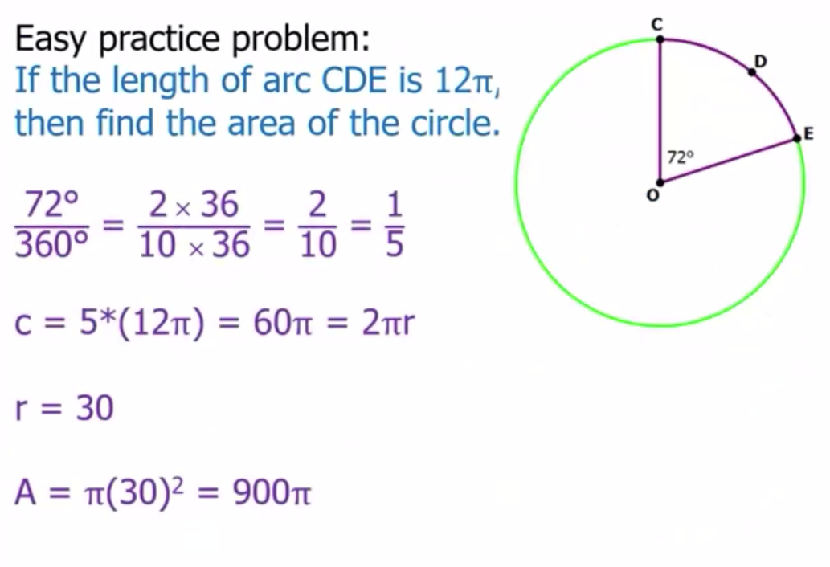

1. Circular Sector

1. Formulae for Circular Sector

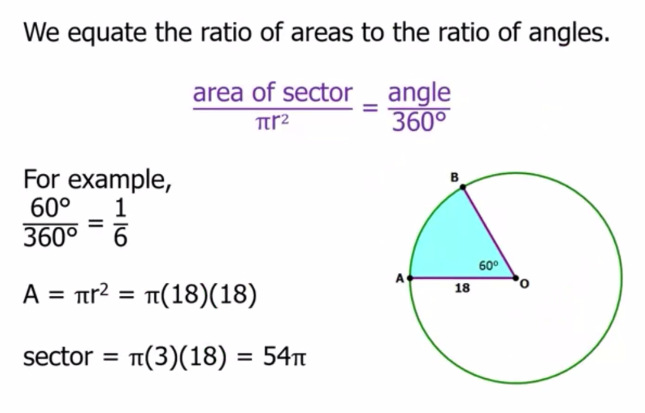

1. Problem for Sector

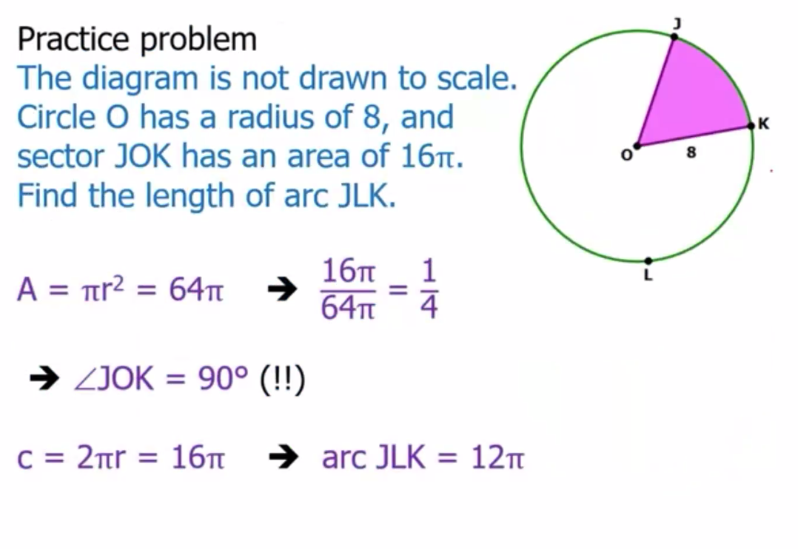

1. Summary

